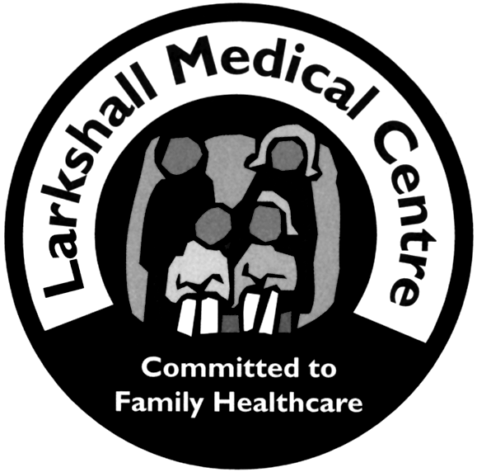
Larkshall Medical Centre
1 Larkshall Road,
Chingford
London, E4 7HS
Tel 020 8524 6355
Fax 020 8524 0605

Accessing your GP-held records via the NHS app or NHS website
As your GP practice, we have been asked to provide you with access to your future medical records going forward via the NHS app (and NHS website) if you have a suitable NHS login
Your GP medical record contains consultation notes based on conversations between you, your GP and their team: medicines prescribed to you; all test results including hospital investigations; allergies; vaccines; and your medical conditions along with documents that may have been sent from local hospitals, clinics or other agencies, eg the police. There is likely to be sensitive and personal information within your medical record.
We are supportive of providing you with access to your prospective or future record, but we wish to do this safely and make you aware that this is happening so that you can opt out, if you so wish.
You may wish to speak with us first to understand what it is that you will see, and the risks which may be involved in having such confidential data either on your smartphone with the NHS app installed or online if other people might have access to that information through your devices.
If you are in a difficult or pressured relationship for example, you may prefer your records to remain accessible only to those treating you, with them not appearing on your smartphone or online. Government has been clear that if a patient does not wish to have access, then we do not have to provide it. This is one reason why we have asked if you wish to opt out, or have it switched off for the time being.
It is important to remember that these documents may, at times, contain information that could be upsetting, especially if they contain news of a serious condition. It can also be a cause for worry seeing results online when it is not clear what the results might mean, and no one is available to ask, as can be the case during the evening or at weekends, for example.
Sometimes people with a mental health condition will not have access to records for safeguarding reasons or that remind them of difficult times in their life.
It is possible for individual items tmay be redacted until the doctor or nurse has explained contents with you. Other items can be hidden at your request. The author of documents are best placed to answer any queries you may have for example hospital letters.
Great care is also needed in case private details might cause harm at home, should people in a difficult or pressured relationship be forced to show their medical record to an abusive partner. Anyone in such a position should make this clear to us at the practice, so we can take steps to keep you safe. This might mean removing access through the NHS app for the time being, or through a careful process where we hide sensitive things. We would talk this through with you.

Requesting access – what do I need to do?
The easiest way to get access is to create an NHS login through the NHS app. Although you can also access your GP records via the internet on a computer, the first bit is easiest if done through a smartphone. If you do not have one, you may have a family member or friend you trust who can help you. You can also ask your practice receptionist, but you will need some proof of who you are, eg a passport, driving licence or household bill.
If you use the NHS app, you’ll have to set up an account using a unique e-mail address and then ‘authenticate’ yourself to the NHS system to prove you are who you say you are. This will involve confirming your name, date of birth and contact details. The NHS login has several levels of authentication and to gain access to your records you will need the highest level of authentication. This generally involves you recording a short video of yourself to prove you are a real person as well as uploading a copy of a suitable identification document. Once you have suitably authenticated yourself to the NHS app and created your NHS login you can approach your practice and ask for access, being mindful of the risks associated with access and the importance of not sharing passwords or having them stored in your smartphone if you think other people might want to see them without your permission. If you have any concerns, you should explain these to your GP practice team who can guide you.
Your GP practice will have a form they will ask you to complete either by SMS or in writing, with your NHS login and then you will have a chat about online access for repeat prescription and access to future records and your agreement and understanding will be requested. Once you are happy to get online access, your request will be passed to the clinical team to review. It may be that the practice wishes to contact you to discuss your request if there are any concerns raised so that access can be given safely. We are not sure how many people will ask for access all at once so there may be a wait, but we will do our best to get you online access as soon as we can.
To request online access please submit e-Consult and chose the admin option or call reception on 02085246355.

